December Newsletter 2022

Advent has begun here at St Joseph’s NS Mulhussey and there is a lovely, festive atmosphere to be seen and heard around the school building!

Christmas Wonderland
The Parents Association are working hard behind the scenes to ensure our school building is going to look festive with Christmas lights. Monday the 12th December is the date set for the lights to be switched on this year and we look forward to it!

Whole School Advent Calendar
We teach the children that Advent is a special time of preparation for the birth of baby Jesus. With this in mind, we have started a whole school Advent Calendar which is on display in the school corridor. The Students Council unveil a random act of kindness suggested for that day to be practiced in school and at home. Four children in the school also receive a small treat each day.

Christmas Carol Service
Our Christmas Carol Service will take place on Thursday 15th December in Kilcloon Church at 11:30am. The children have been practising for a few weeks now and sound wonderful! Students will travel to and from the church by bus. Students will return to school with their class and teachers directly after the carol service. The Parents’ Association Committee have organised tea, coffee and a Christmas raffle for parents after the carol service.

Retirement
On Friday 25th November, school staff and Fr Declan representing the Board of Management, made a presentation to Martina Staunton on her retirement. Martina has been one of the cleaners here at St Joseph’s for 22 years and has always been a much valued member of our staff. We wish her the very best of luck as she embarks on the new adventure of retirement!

Biodiversity and Irish Heritage Council
On Friday 25th November, we welcomed Ross from the Irish Heritage Council who gave each class an extremely interesting and informative outdoor workshop which was enjoyed by all.

Parent Teacher Meetings
Thank you to staff, parents and guardians for a successful week of Parent Teacher meeting in the school.

Bad weather (ice)
It is not always possible for staff to put salt on the yard or carpark so parents should be careful when walking the children to their line in the morning. The school will open to receive pupils at 9.10am. No responsibility is accepted for pupils arriving before that time.

Illnesses
We continue to encourage children to practice good hygiene by coughing into the elbows, sneezing into a tissue and discarding of it in the appropriate bin and washing and sanitising their hands regularly. We also ask parents to continue to keep children who are unwell at home until they are fully better to avoid the spreading of illnesses within the school community.

Substitute Teachers
Highlighted in the media recently, there is a significant shortage of substitute primary school teachers available nationwide at present.

Parents Association
Parent Association fundraising proceeds, enable the school to provide an enriched curriculum to the students in our care. As a school we recognise the importance of students being involved in experiential learning opportunities including extra-curricular events and initiatives where students' holistic development can be nurtured. Particularly post-Covid restrictions, we endeavour to provide our students with learning opportunities beyond the classroom.
Fundraising proceeds have benefited students across the school over the first term of the academic year by enabling the purchase of sports equipment which already has been put to tremendous use at yard time and during PE lessons. We look forward to our new basketball board and net being put up soon as we know it will be used daily.

As well as this, fundraising proceeds has contributed to covering costs for learner experiences for our students including a Science Show by Junior Einstein as part of Science Week and an outdoor workshop on Biodiversity and Folklore with Heritage Specialist Ross Cochrane which was part funded by the Heritage in Schools Scheme by the Heritage Council of Ireland. These learner experiences were interactive, engaging and enjoyable for our students but also enhanced their knowledge, skills and oral language in these particular areas.
Fundraising proceeds have also subsidized bus transportation costs which enabled our students to be part of several events and initiatives all of which are and were extremely beneficial for students in so many ways. These events and initiatives include Cumann na mBunscol, Peace Proms, Our Christmas Carol Service and Literacy Focused visits to Dunboyne Library.
We would like to extend our sincere thanks and gratitude to the whole school community for your generous contributions to fundraising events held by our school Parent Association Committee. As you can see in the first term alone the proceeds have greatly benefitted the learning opportunities of the children across the school. Thank you also to our dedicated Parent Association Committee for your organisation of fundraising events along with other areas. Parental involvement in your child's education is powerful and research has identified the benefits it has for students, parents, teachers and the school itself. Míle buíochas go léir.'

Some photos from a few of the events that the children have attended this term so far thanks to the fundraising efforts of the Parents
Association.

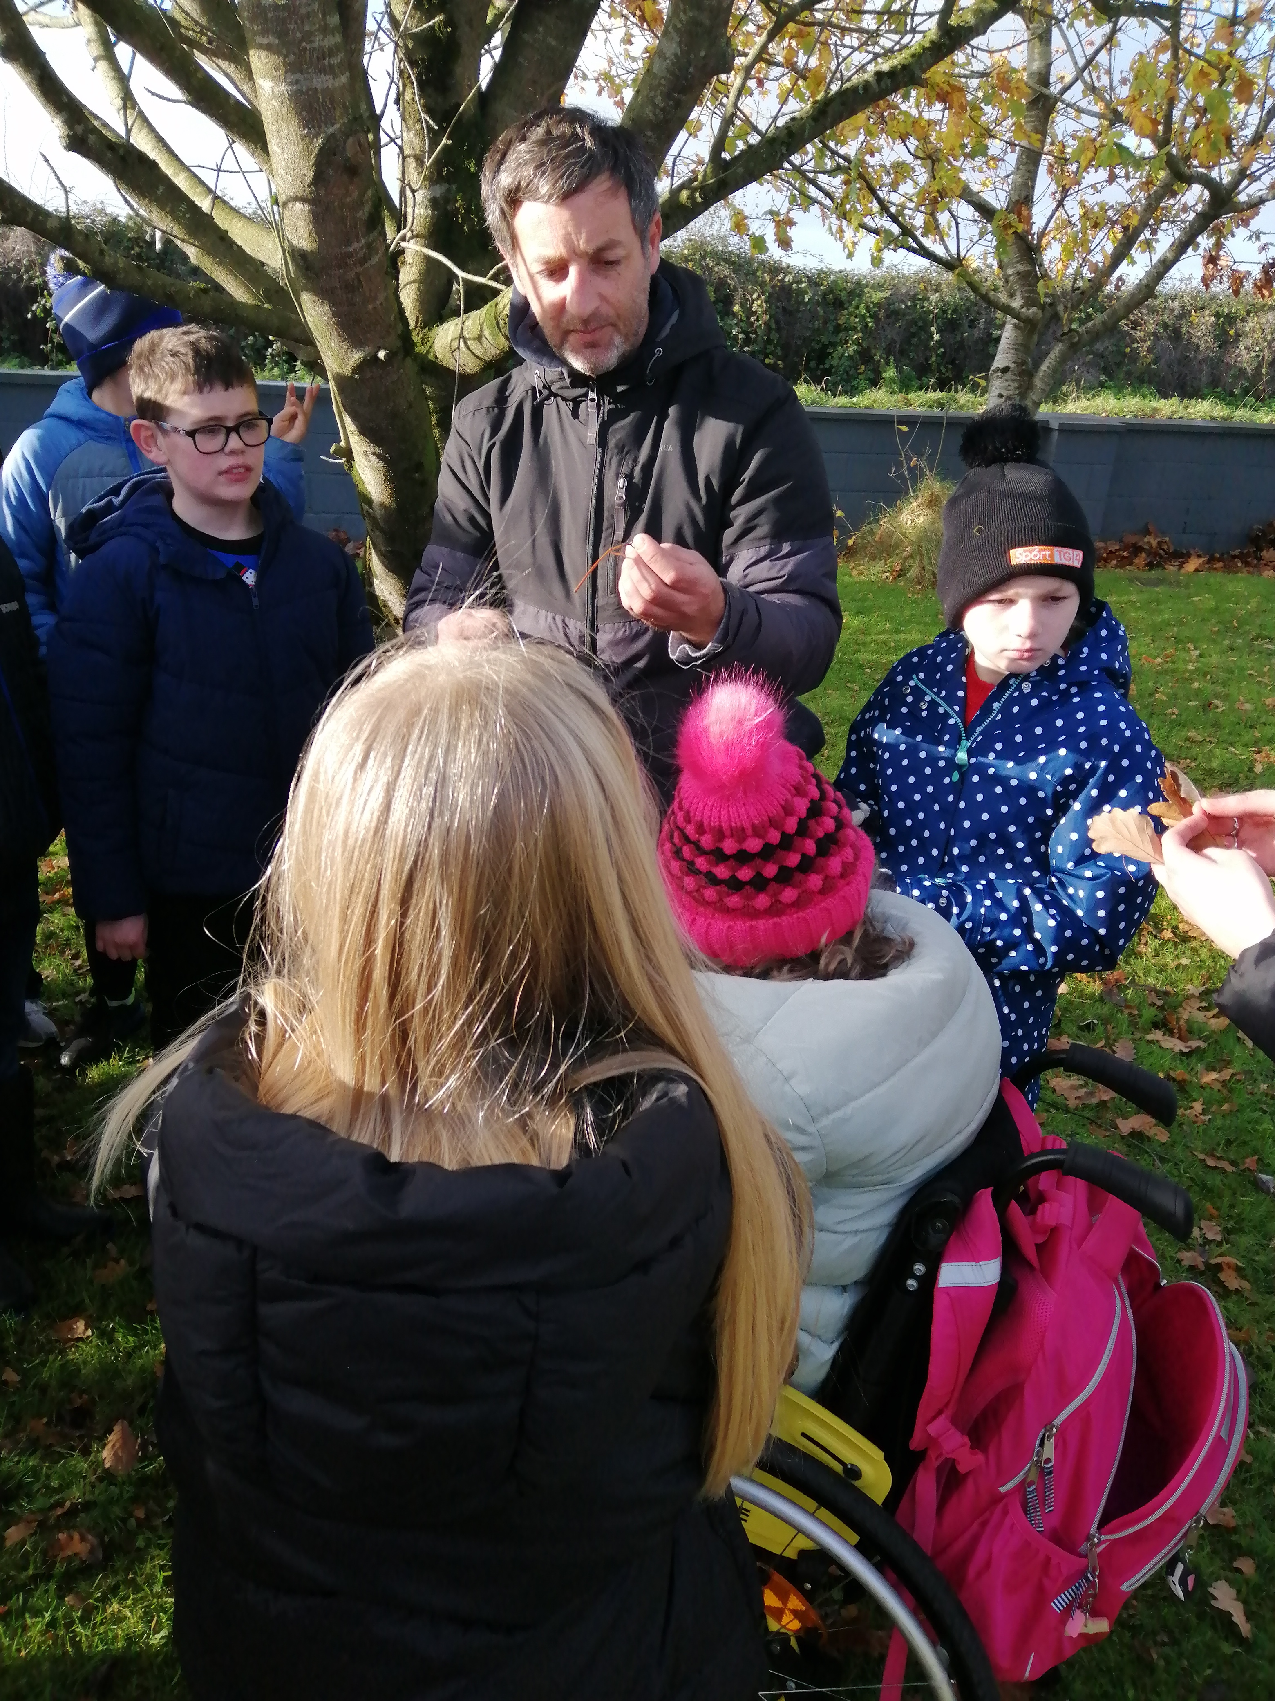

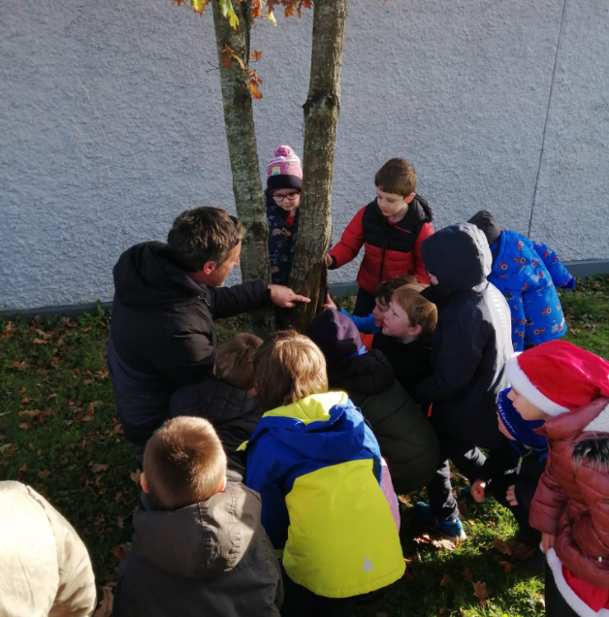

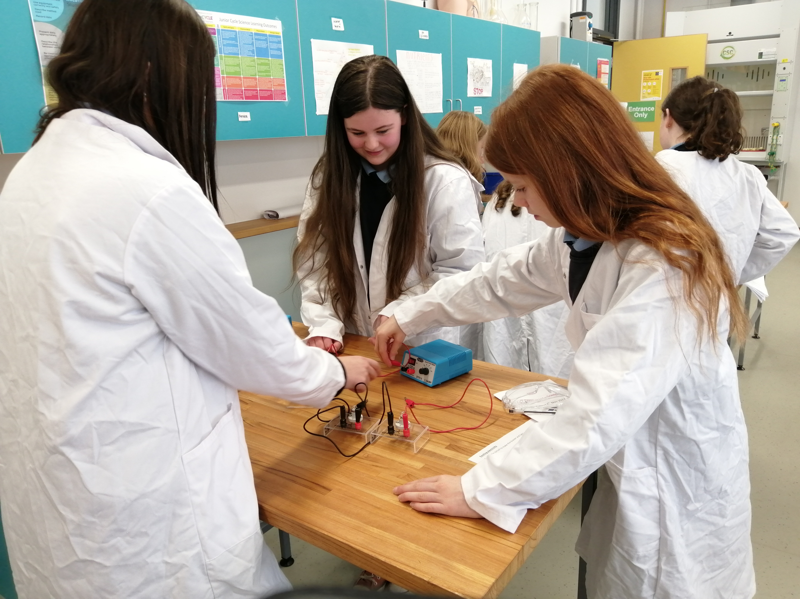

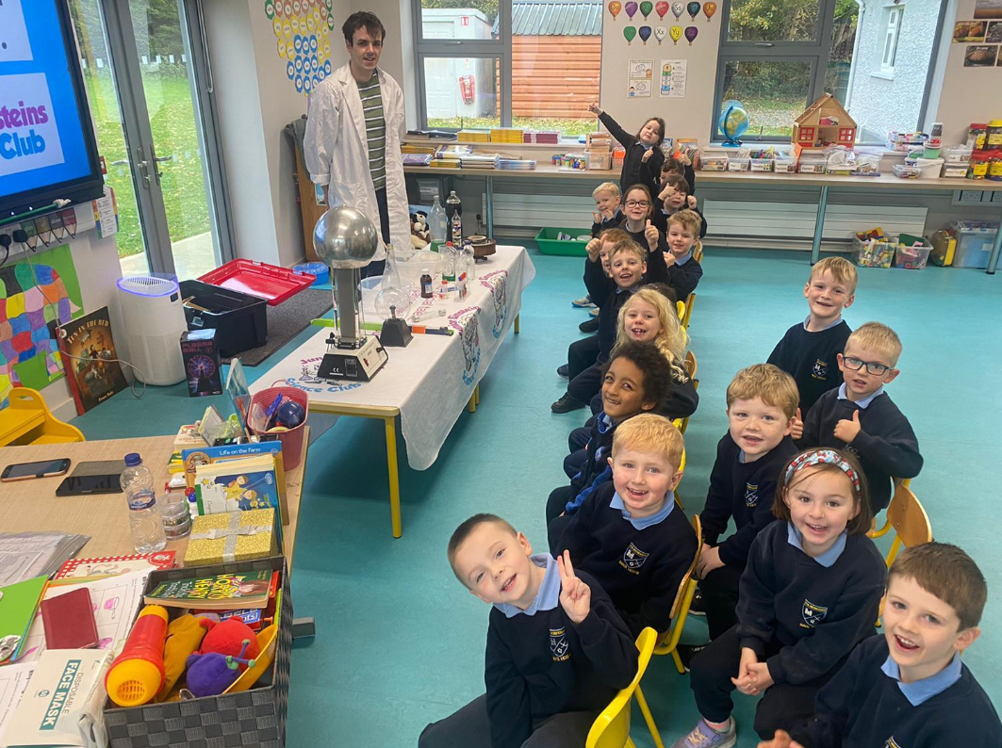

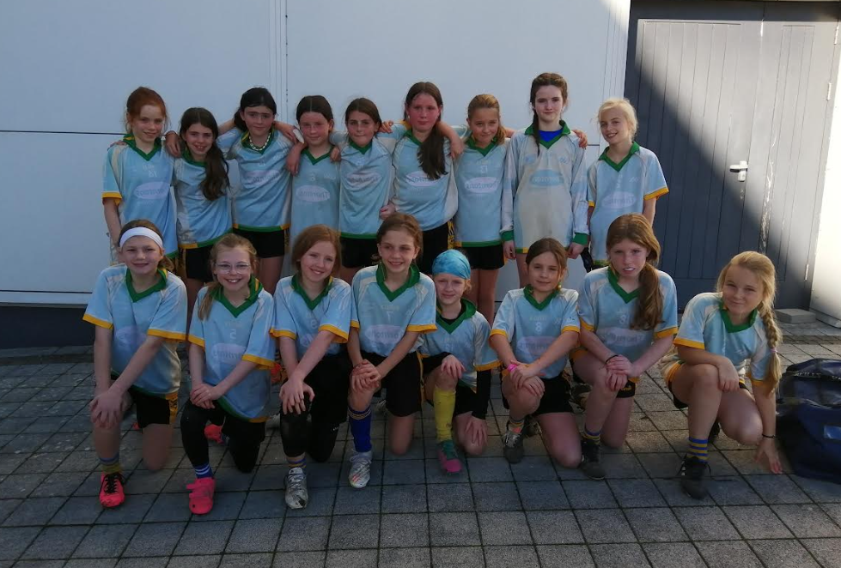

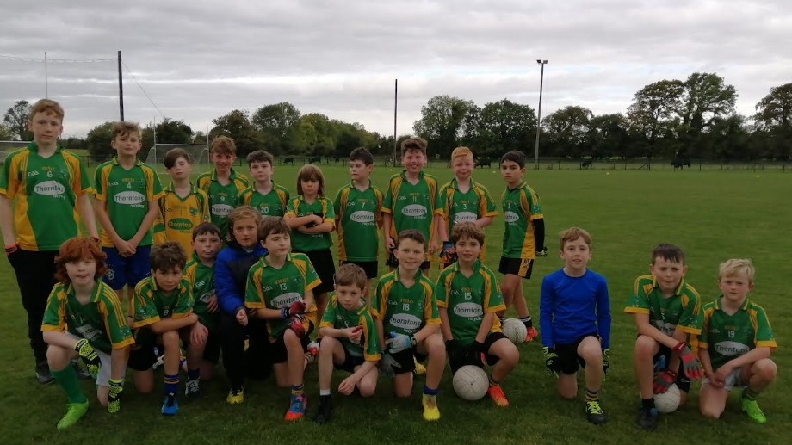

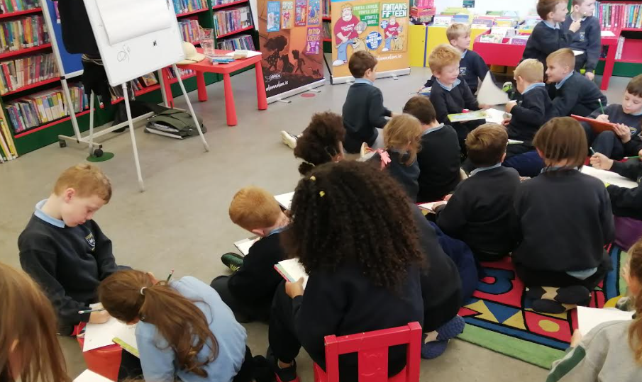

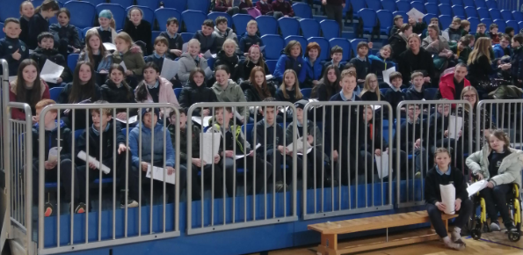

Dates for Your Diary
15th December Carol Service in Kilcloon Church @11:30am
21st December Christmas holidays: school finishes at 12pm
5th January School reopens at 9:10am

